

Bansilal Ramnath Agarwal Charitable Trust’s

# Vishwakarma Institute of Information Technology

Business Intelligence and Data Analytics

(Assignments 1)

|  |  |  |  |
| --- | --- | --- | --- |
| Name | Roll No. | GR No. | Batch |
| Chetan Chinchulkar | 324017 | 21810350 | E9 (Comp D) |
| Nikit Gokhe | 324022 | 21810522 | E9 (Comp D) |
| Sahil Langha | 324032 | 21810533 | E9 (Comp D) |
| Kunal Parkhe | 324040 | 21810049 | E9 (Comp D) |

GROUP MEMBERS:

# Assignment No. 01

# Aim:

Design Decision support system for any suitable application

The data is related with direct marketing campaigns (phone calls) of a Portuguese banking institution. The classification goal is to predict if the client will subscribe a term deposit.

**(Use Weka/Power BI/Excel)**

# Objective:

1. Create Dashboard using Power BI.
2. Predict Clients Decision

(predict if the client will subscribe a term deposit.)

# Theory:

* A decision support system (DSS) is a computer-based information system that supports business or organizational decision-making activities.
* DSSs serve the management, operations, and planning levels of an organization and help to make decisions, which may be rapidly changing and not easily specified in advance.
* DSSs include knowledge-based systems. A properly designed DSS is an interactive software-based system intended to help decision makers compile useful information from a combination of raw data, documents, personal knowledge, or business models to identify and solve problems and make decisions

# Input:

**Name:** Bank Customer Data

**Dataset Reference:** kaggle

**Link:**

<https://www.kaggle.com/kidoen/bank-customers-data>

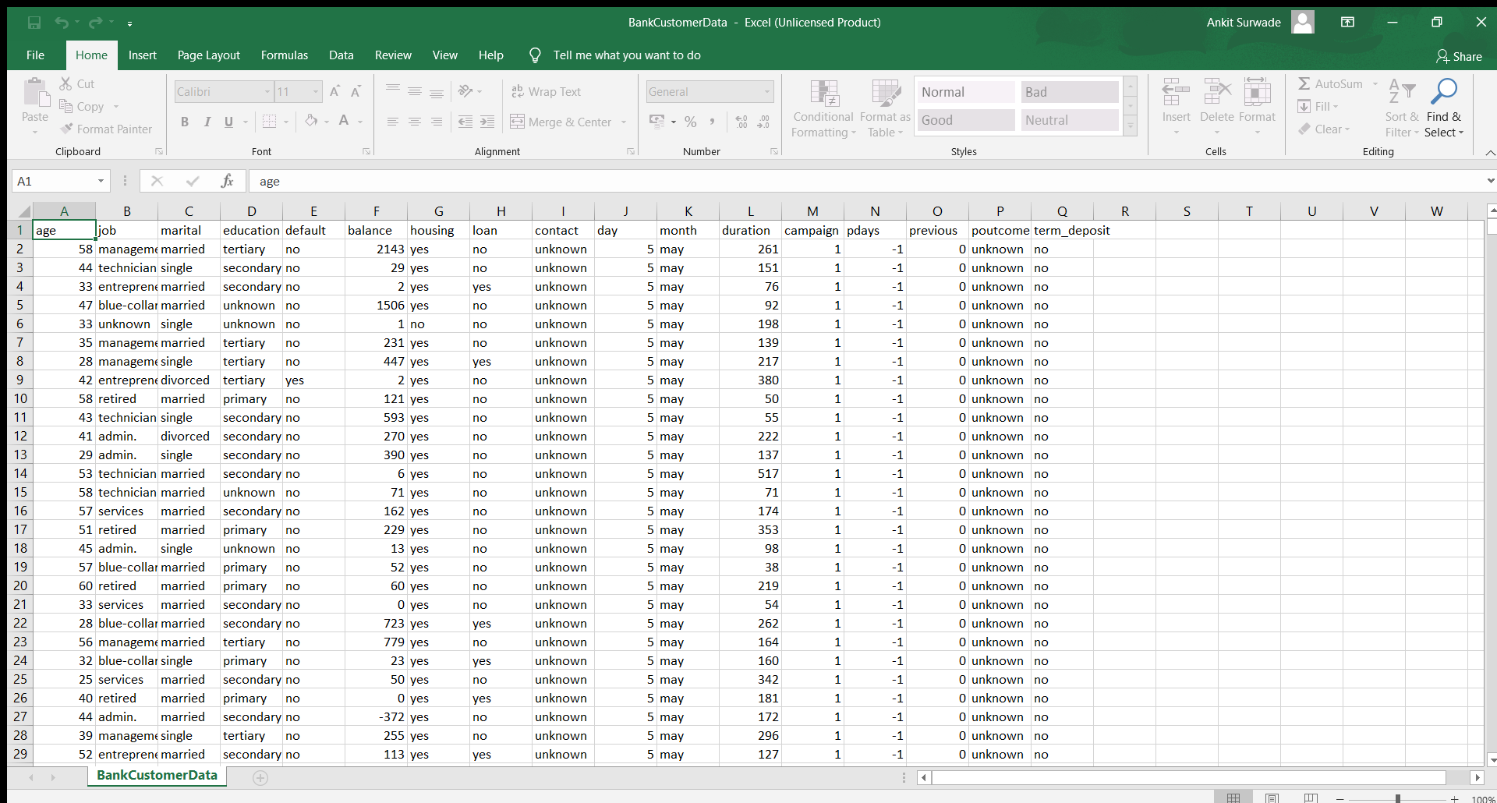

# Output:

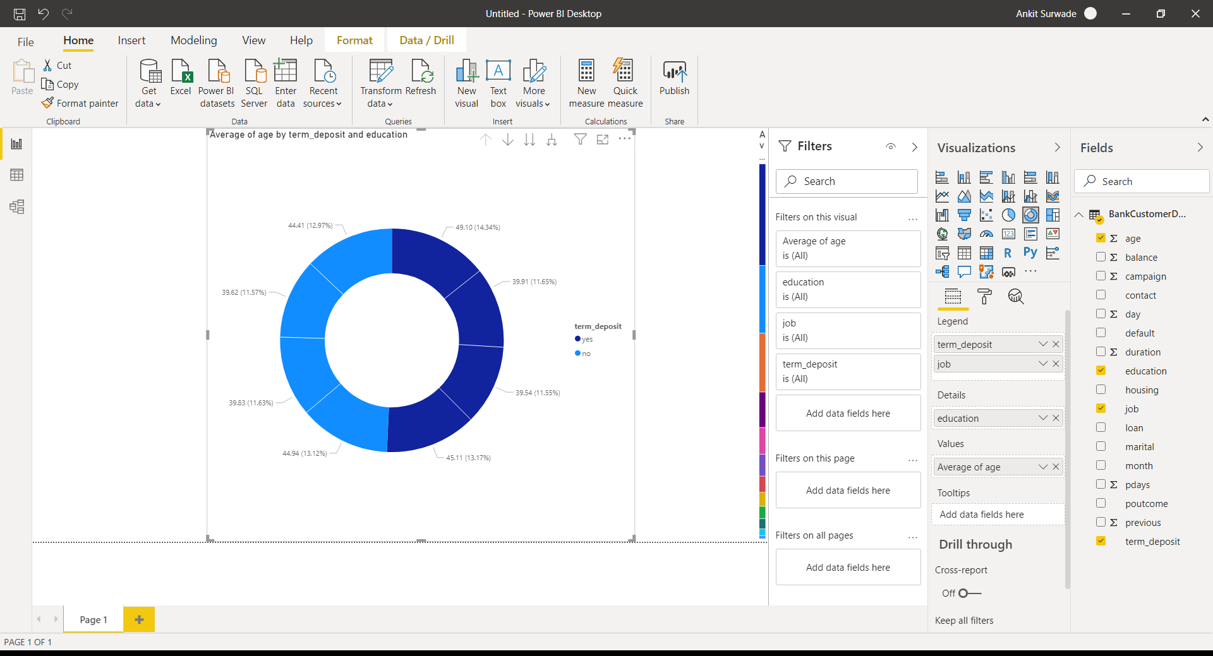

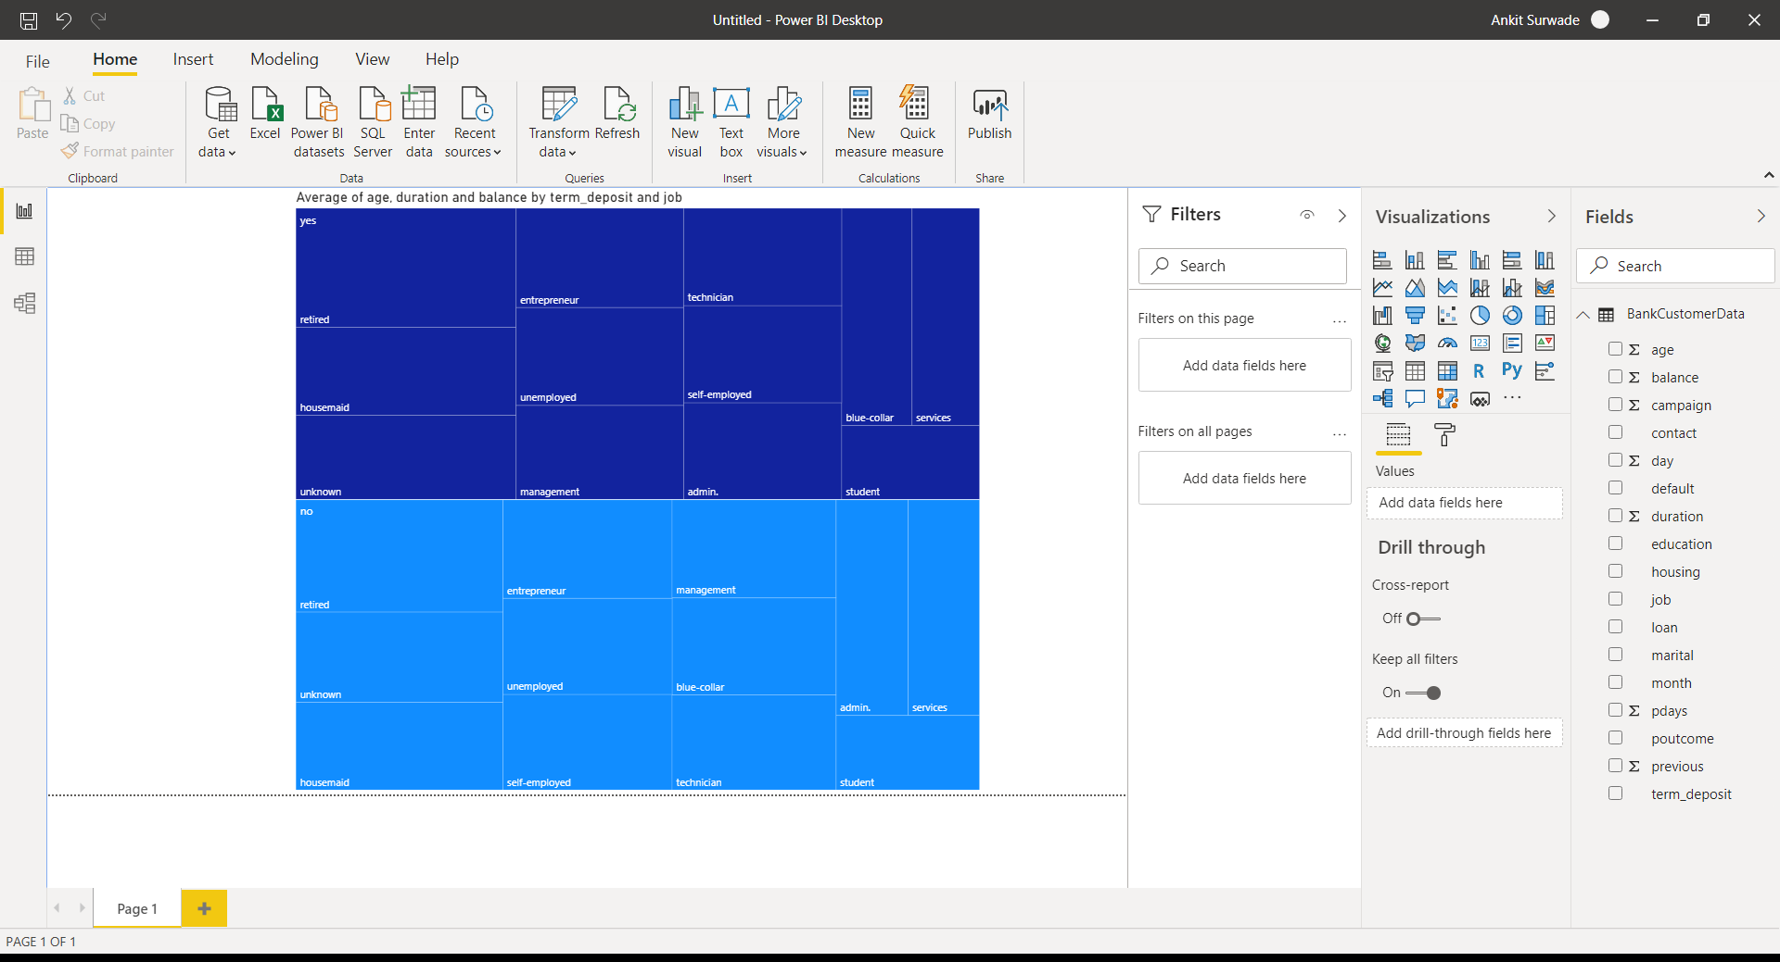

# Conclusion:

1. We can create sheets and dashboards in Power BI easily.
2. It is much user friendly software.
3. Easy to make decision taking dashboards.
4. Plenty of different visuals are available.